Appendix B – Manufacturer’s CLS Product Information
This form is available in a Microsoft Word version from the ENA’s website.
G100/2 - Form B - Compliance Verification Report for Customer Export or Import Limitation Schemes
This form shall be used by the Manufacturer to demonstrate and declare compliance with the requirements of EREC G100. The form can be used in a variety of ways as detailed below:
1. For Fully Type Tested status
The Manufacturer can use this form to obtain Fully Type Tested status for a CLS by registering this completed form with the Energy Networks Association (ENA) Type Test Register.
2. To obtain Type Tested status for a product
The Manufacturer can use this form to obtain Type Tested status for one or more Components which are used in a CLS by registering this form with the relevant parts completed with the Energy Networks Association (ENA) Type Test Register.
3. One-off Installation
The Installer can use this form to confirm that the CLS has been tested to satisfy the requirements of this EREC G100. This form shall be submitted to the DNO before commissioning.
A combination of (2) and (3) can be used as required, together with Form C where compliance of the CLS is to be demonstrated on site.
Note:
If the CLS is Fully Type Tested and registered with the Energy Networks Association (ENA) Type Test Register, Form C shall include the Manufacturer’s reference number (the Type Test Register system reference), and this form does not need to be submitted.
Where the CLS is not registered with the ENA Type Test Register or is not Fully Type Tested this form (all or in parts as applicable) shall be completed and provided to the DNO, to confirm that the CLS has been tested to satisfy all or part of the requirements of this EREC G100.
CLS Designation
Manufacturer’s reference name |  | SiH-5kW-SH，SiH-6kW-SH  SiH-3.6kW-SL，SiH-5kW-SL，SiH-6kW-SL
Manufacturer name |  | Shanghai Sieyuan Watten Technology Co., Ltd.
Address |  | Room 306, Building 1, HuaNing Road-No.3399, Minhang District, 201108 SHANGHAI  P.R. CHINA
Tel | 86-21-61610846 | Web site | www.swatten.com
E:mail | swatten@sieyuan.com
Installer’s name
Address
Tel |  | Web site
E:mail

Export/Import capabilities
Export | Y | Import | N
Description of Operation
EREC G100 section 4.2 requires a description of the CLS, and schematic diagram, to be provided to the Customer. Please provide that description and the diagram here.
The Shanghai Sieyuan Watten smart energy management solution is based on master-slave control.The master is responsible for implementing the logic of G100-2 CLS.The master is responsible for communicating with the slave, the electricity meter at the connection port, and the upper computer.
Shanghai Sieyuan Watten CLS Controls & Settings
Shanghai Sieyuan Watten smart energy management system meets the EREC G100 version 2 policy requirements through the following advanced controls and strategies
- Shanghai Sieyuan Watten electricity meter (monitoring energy exchange with the grid): The electricity meter can monitor the current of the smart energy system and the grid in real time, and transmit this data to the master,which ensure that all input and output currents are captured by Shanghai Sieyuan Watten CLS. For multiple incomers, the master will control the values according to DNO requirements to ensure that the required import / export currents are provided correctly
- Shanghai Sieyuan Watten Control Response Time: The Shanghai Sieyuan Watten CLS response time are compliant to the G100 requirements and will enter the State 2 within 15 seconds
- Shanghai Sieyuan Watten State 1, 2 & 3: Shanghai Sieyuan Watten ’s smart energy management solution meets the requirements of state 1, 2 and 3 in G100 2nd amendment policy (timing and allowable number of attempts).
- Shanghai Sieyuan Watten Interrogation & Data: Shanghai Sieyuan Watten will capture all control and inverter data and upload it to the upper computer for real-time display,which enables real-time data monitoring for users .

Single Inverter

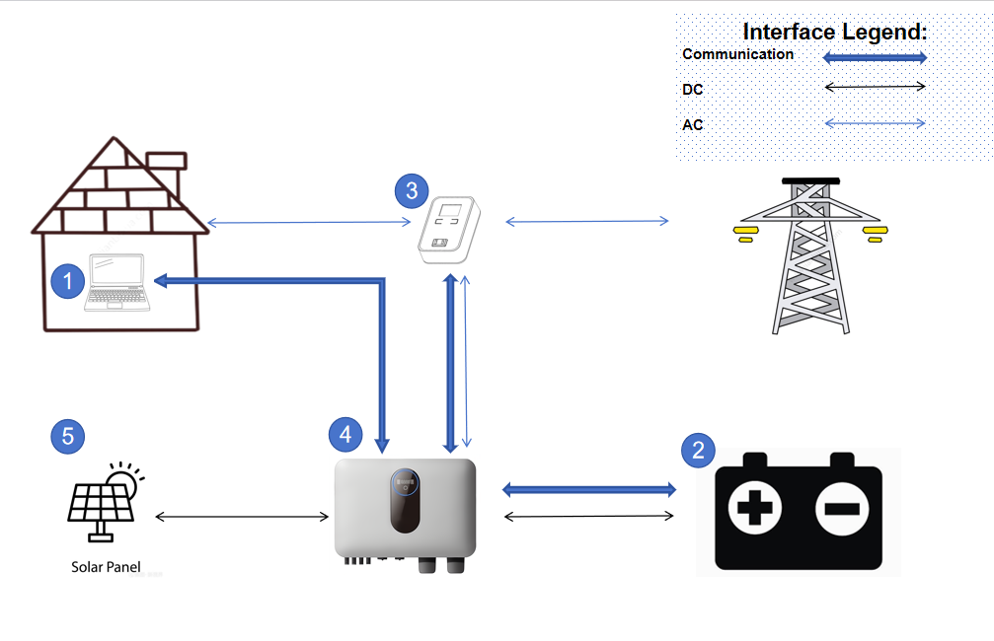

Multi Inverter

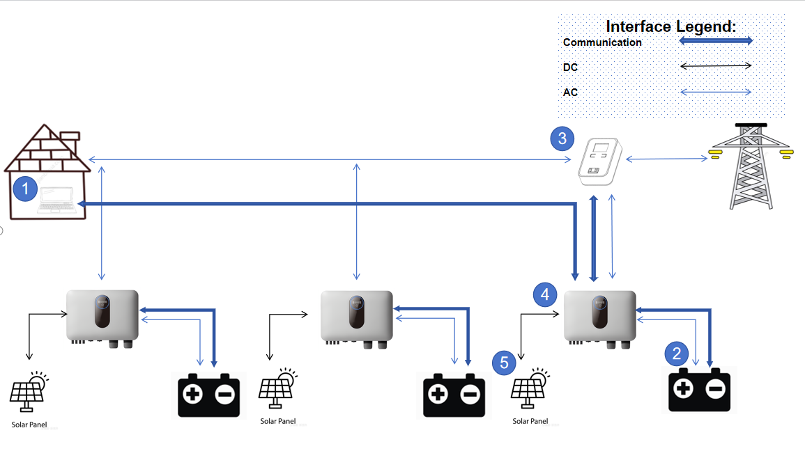

No. | Product type | Icon | Product number
1 | Human-computer interaction interface |  | /
2 | Energy storage battery |  | /
3 | Electricity meter |  | ADL 200
4 | Inverter |  | SiH-5kW-SH  SiH-6kW-SH
5 | PV |  | /

Communications Media
Document the provisions made for the use of various communication media, and both the inherent characteristics and the design steps made to ensure security and reliability.
The communication medium supporting CLS can be wired or wireless.The control logic of G100 will be reflected through CLS devices.
- Shanghai Sieyuan Watten ’s solution for CLS internal communication: The CLS system consists
of the following components：
  - Hard-wired serial Modbus RTU
  - Hard-wired wired communication (LAN)
  - Hard-wired serial dedicated protocol (over RS485)
  - Standardized wireless communication (Wi-Fi)
- Shanghai Sieyuan Watten ’s solution for ‘Local Network’ Communications: All units in the CLS
system are connected through "hard wired" or dedicated communication cables,there are no third-party devices connected to this network, forming a closed-loop fence local network.
- Shanghai Sieyuan Watten ’s solution for remote communications: The CLS system can
communicate remotely through the user's local area network.

Cyber Security
Confirm that the Manufacturer or Installer of the CLS has provided a statement describing how the CLS has been designed to comply with cyber security requirements, as detailed in section 4.7.
We Shanghai Sieyuan Watten Technology Co., Ltd declare that G100 certified products,
Are in compliance with Cyber security requirements in accordance with the standards:

- G99 Issue 1 Amendment 8 2021;
- ETSI EN 303 645;
- PAS 1879 “Energy smart appliances – Demand side response operation – Code of practice”;

Power Quality Requirements
Where the CLS includes the power electronics that controls generation or loads (as opposed to the power electronics being included in Devices that are subject to their own power quality compliance requirements) please submit the harmonic and disturbance information here as required by EREC G5 and EREC P28.
Not applicable to our system as it is not a stand-alone device, and it works as a system.

Fail Safe
CLS internal failure: please submit here the description of the internal Fail Safe design and operation. Please also document how it has been demonstrated, including the non-volatile recording of times and numbers of state 2 operations, and confirm the overall response of the CLS to this internal failure.
Fail safe operation
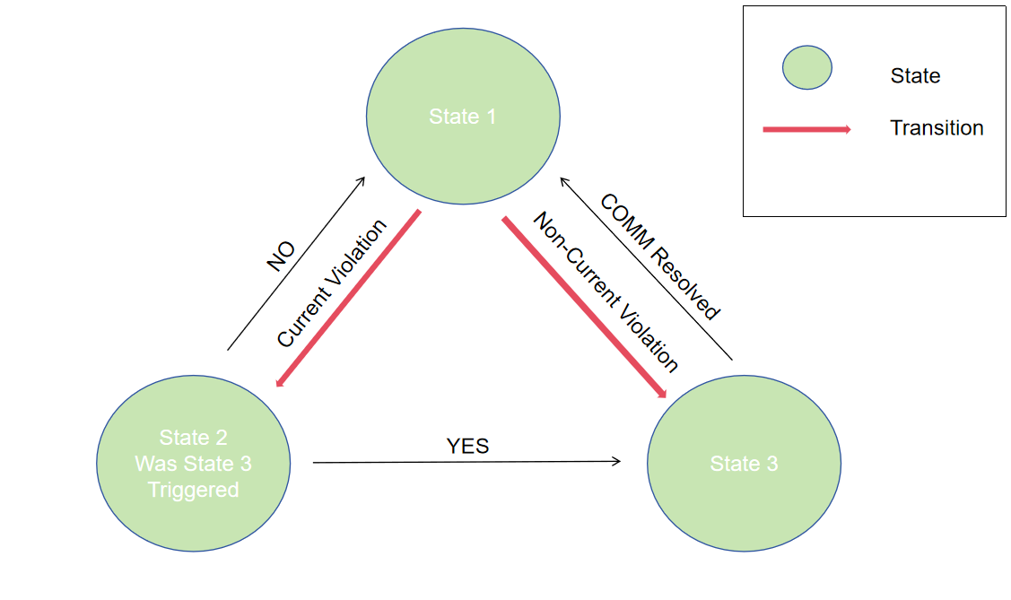
The Shanghai Sieyuan Watten G100 CLS incorporates a fail-safe mechanism as outlined in Section 4.5 of the G100 specifications. This ensures that the Shanghai Sieyuan Watten system design effectively limits the imported/exported current at the site to comply with the agreed limit(s) set by the DNO.
All components within the Shanghai Sieyuan Watten system, whether wired or wireless, are registered by the CLS during the commissioning process, where each device is designated as either a generation or non-generation device.
In the event of a detected failure, the system will activate the fail-safe mechanism by immediately reducing the generation of the component to zero, in accordance with the provided table.
(1) Internal Fail Safe typically denotes a scenario where the device malfunctions, rendering it unable to operate effectively and impacting the CLS. Upon detecting a fault, the CLS mandates the cessation of inverter operations and prompts reporting to the cloud platform. In instances of communication breakdown, encompassing both inverter and meter communication issues, the inverter must likewise cease operations and relay the situation to the cloud platform.
(2)The inverter will continuously track the status of the CLS system, logging the duration and frequency of each occurrence when the CLS transitions into states 2 and 3. These recorded data will be stored in the EEPROM, persisting even in the event of power loss and subsequent restart.
(3)The inverter will remain in the CLS Fault state until the issue is resolved. Upon resolution, the CLS will promptly transition to state 1, and the inverter will return to its normal operational state.
(4)This mechanism can be illustrated by examining the CLS state when power supply is removed or restored to any individual sub-component.
Communication and power supply failures between Components and Devices. Please document here compliance with EREC G100 section 5.5.
Component/Device number/description | Communication failure test | Power supply failure test
Disconnect communication between inverter and Electricity meter | PASS | PASS
Under normal operating conditions, The Power grid value is reduced to 0W Inverter response time | PASS | PASS
Under normal operating conditions, The Power grid value is reduced to 2000W Inverter response time | PASS | PASS

Operational Tests
In accordance with EREC G100 section 5.6 undertake the tests A to D to confirm correct operation in state 1 and state 2, that transition into state 3 occurs as required, and that behaviour in state 3 is also as required.
Test A
Nominal Export Limit (for type tests this will be at maximum, minimum and one intermediate setting) in Amp: |  |  |  |  |  |  | 27.3A
Nominal Import Limit (for type tests this will be at maximum, minimum and one intermediate setting) in Amp: |  |  |  |  |  |  | 27.3A
No | Starting level | Step value | CLS registers change in level? | CLS and/or Component and/or Device initiates correct response of ≥ 5%? | Duration of step in test | Correct state 1/  state 2 operation
1 | 27.2 IAC | 27.5 IAC | Yes | Yes | 58s | 1 > 2 > 1
2 | 27.3 IAC | 27.4 IAC | Yes | Yes | 58s | 1 > 2 > 1
3 | 27.1 IAC | 27.6 IAC | Yes | Yes | 58s | 1 > 2 > 1
4 | 27.4 IAC | 27.7 IAC | Yes | Yes | 58s | 1 > 2 > 1
5 | 27.0 IAC | 27.3 IAC | Yes | Yes | 58s | 1 > 2 > 1
6 | 27.4 IAC | 27.4 IAC | Yes | Yes | 58s | 1 > 2 > 1
Test B
Nominal Export Limit:
Nominal Import Limit
No | Starting level | Step value | CLS registers change in level? | CLS and/or Component and/or Device initiates correct response of ≥ 5%? | Duration of step in test | Correct state 3 operation
7 | 28.6 IAC | 28.9 IAC | Yes | Yes | 62s | 1>2>3
8 | 28.7 IAC | 28.8 IAC | Yes | Yes | 62s | 1>2>3

State 3 Reset
These tests are to demonstrate compliance with section EREC G100 4.5.2.
Please document how the reset from state 3 to state 1 has been demonstrated. Please include how the reset is achieved.
Please confirm that for CLSs to be installed in Domestic installations three (3) resets causes lockout or that for non-domestic installations lockout can only be reset after four hours. Please explain how lockout is reset.
1. System state is "State 3”.
2. After the communication is restored, the grid will be connected again.
3. CLS changes system state to "State 1 - Normal Operation".

